**Hw4**

(1) result screenshot

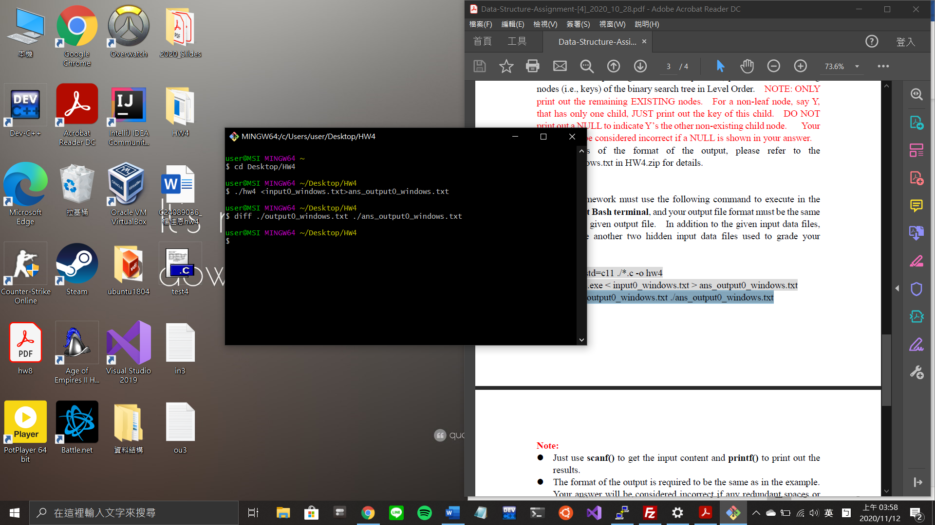

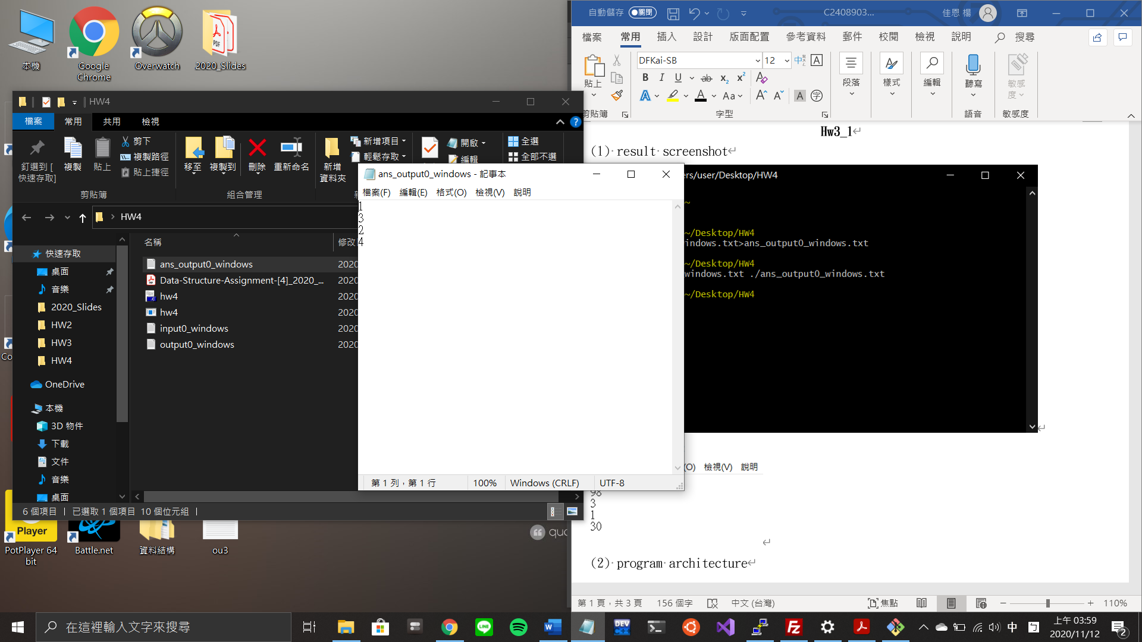

(2) program structure

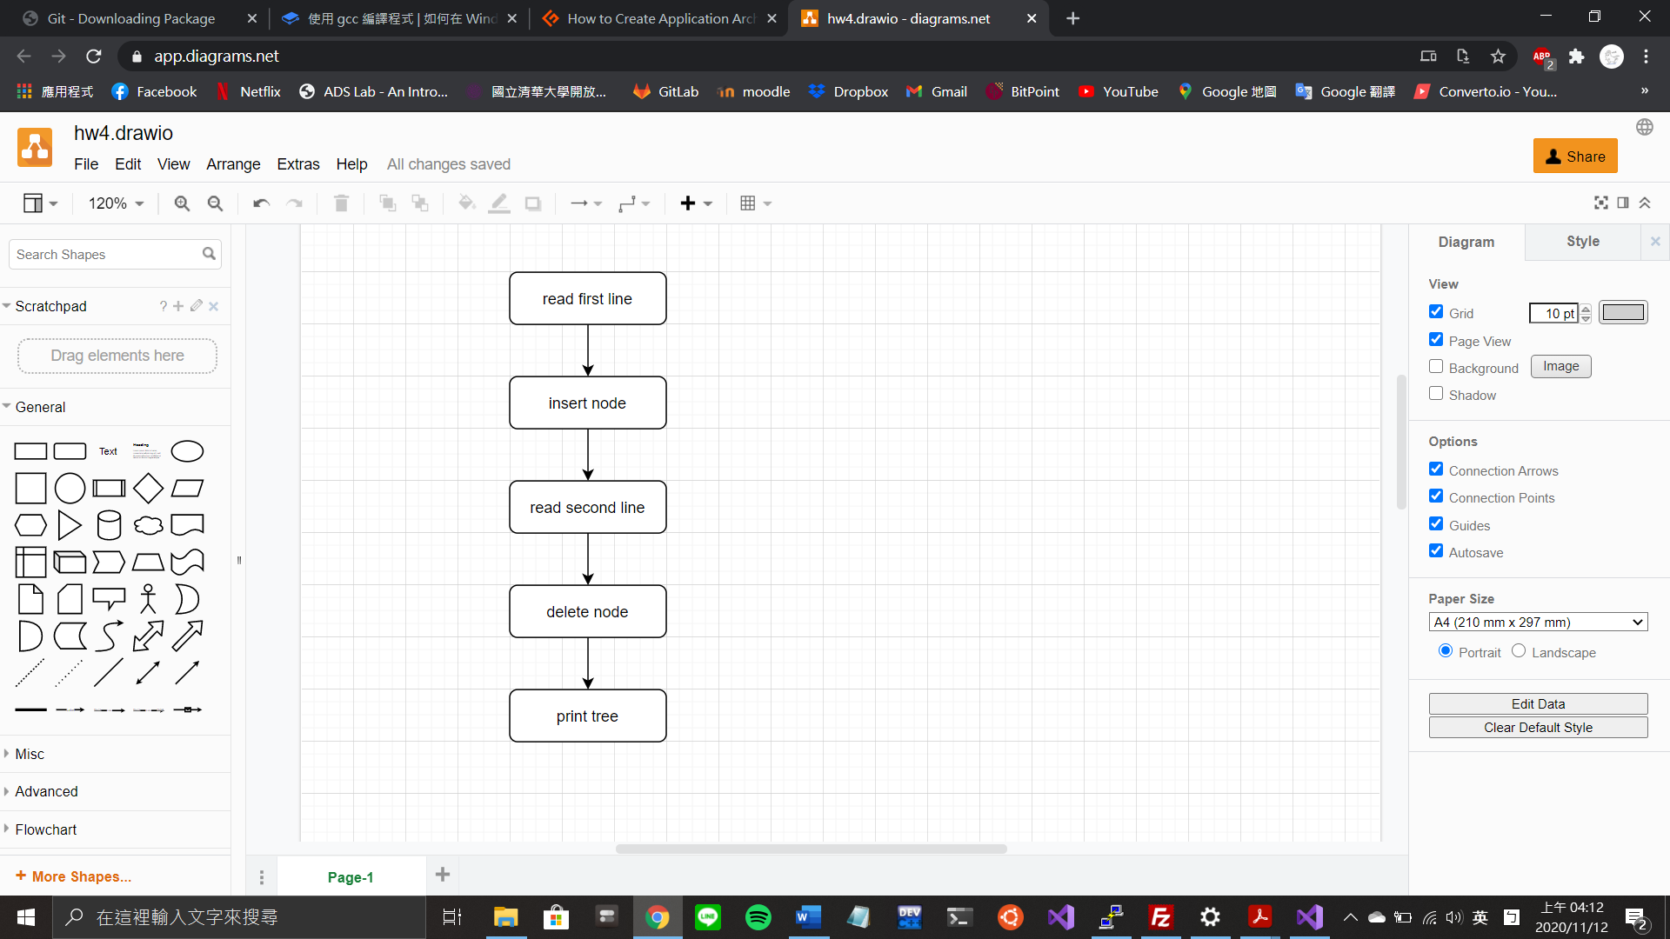

(3) program functions

void level_order(tree_pointer ptr);

Features

以level order印出binary search tree

Parameter

search tree的root pointer

Return Value

None

tree_pointer search(tree_pointer root, int key);

Features

搜尋要插入node的前一個位置

Parameter

search tree的root pointer

Return Value

即將插入node的前一個位置

void insert_node(tree_pointer* node, int num);

Features

加入新的node到search tree

Parameter

node – search tree的root pointer的pointer

num – 要加入的數字

Return Value

None

tree_pointer minValueNode(tree_pointer node);

Features

搜尋tree中的最小值

Parameter

search tree的root pointer

Return Value

tree中最小值的pointer

tree_pointer delete_node(tree_pointer root, int key);

Features

刪除node

Parameter

root – search tree的root pointer

key – 要刪除的數字

Return Value

新root pointer